**Dual Camera based Face Recognition based Real Time Attendance System for Organizations**

**Abstract:**

Face Recognition begins with extracting the coordinates of features such as width of mouth, width of eyes, pupil, and compare the result with the measurements stored in the database and return the closest record (facial metrics). Nowadays, there are a lot of face recognition techniques and algorithms found and developed around the world. Facial recognition becomes an interesting research topic. It is proven by numerous number of published papers related with facial recognition including facial feature extraction, facial algorithm improvements, and facial recognition implementations. Main purposes of this project is to get the best facial recognition algorithm (Eigenface and Fisherface) provided by the Open CV by comparing the ROC (Receiver Operating Characteristics) curve and implement it. This advance Face recognition system can be implemented in 2 cameras kept at both side of entry and monitor both incoming and outgoing persons and their timings and lot more other processes.

**Introduction:**  
An Attendance Management System is a software-based solution used to track and manage employee/student attendance in an organization. With the advancement in technology, the traditional methods of attendance management, such as manual attendance registers or punch cards, have become obsolete. Face recognition technology has emerged as a reliable and efficient alternative to these traditional methods.

The Face Recognition Technology-based Attendance Management System works by using cameras to capture images of employees'/student’s faces and then compares them with a database of pre-registered images to identify the employee/student. The system uses advanced algorithms to match the employee's/student’s facial features, including the distance between the eyes, the shape of the face, and the size of the nose, among other factors, to accurately identify the employee/student.

This system offers several benefits, including improved accuracy and reliability, reduced fraud, and increased efficiency. It eliminates the need for manual input, reduces errors and the likelihood of buddy punching, and enables real-time tracking of employee/student attendance. Additionally, it saves time, reduces paperwork, and provides real-time data analysis and reporting.

In summary, the Attendance Management System using Face Recognition Technology is a modern and efficient way to manage employee/student attendance. It offers accurate and reliable data, saves time and reduces errors, and helps organizations manage their workforce more effectively.

**Problem Statement:**  
Monitoring Student’s incoming and outgoing time in an automated manner and also make a Web based Dashboard to log all the activity regarding individual students. The scope of the system is quite broad and multiple features can be integrated.

**Objective:**

The Objective of the system is build a system with following features:

* Face Recognition technology to log attendance of Students.
* Face Recognition Technology to log the incoming and Outgoing timings of students.
* Notification to Parents in case of late arrival.
* System to send custom alerts to Students and Parents individually or in bulk.
* Profile of each students on Web Dashboard with all the details.
* Admin can get details of the students and Update the Issue Tracker Card.
* Other details about the students can be logged as well.
* Intimation of marks and other information through the Web Dashboard.
* ID Card detection for monitoring discipline.

**Existing System:**

The System uses algorithms like SVM which are primitive and less accurate. And it required more coding and technical knowledge to add new user. Also only Face Recognition not useful by itself and it will be far more beneficial when integrate with systems.

**Proposed System:**

Our Proposed system will use advance algorithms like LBPH which are very accurate and can detect multiple faces at a time. Also, a GUI based app will be made to add new users easily. Finally, A System will be made which will recognise Faces and Mark the attendance in Real-time. The system can be used by organisations with several features of downloading attendance, adding user, view user profile, Adding issues, Sending Custom alerts etc.

**Block Diagram:**

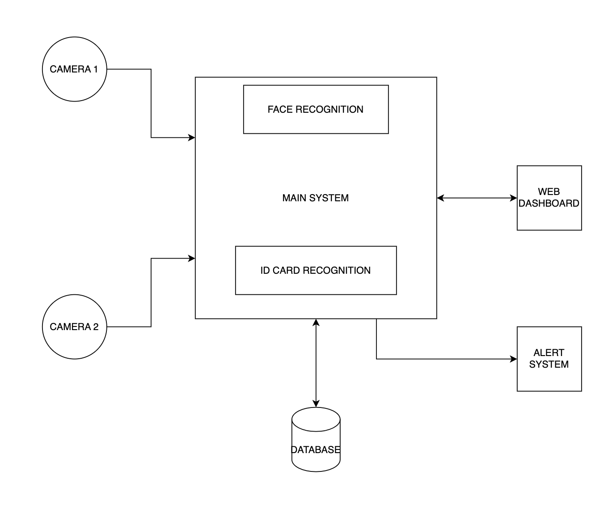

**Requirement:**

Hardware Requirement:

* Laptop/ PC or Raspberry PI Devices
* Webcam
* RAM 4GB
* 120GB + Storage

Software Requirements:

* Python 3
* Machine Learning Algorithm
* Deep Learning ALgorithms
* OpenCV
* LBPH
* SMTP
* Flask
* HTML
* CSS

**MODULES IN PROJECT**

* FRONTEND
* BACKEND SERVER
* CAMERA ACCESSING
* FACE RECOGNITION
* ID CARD RECOGNITION
* MAIL SERVICE

**FRONTEND**  
  
A login UI and data viewer system is a software-based solution that provides users with a secure and user-friendly interface to access and view data. The system typically consists of two parts: a login page and a data viewer pages. The login page allows users to enter their login credentials, such as a username and password, to access the data viewer pages.

Through Data Viewer Pages, The logged-in user can view Live Camera Footage, Attendance, Add New Users, Download Attendance, and many more.

#Add Screenshot of different Web Pages

**BACKEND SERVER**

The Backend Server is a Python Flask Server that facilitates communication of the Frontend Module with other parts of the System. The Backend Server is a very important part of User Interface System.

The backend code of the Face Recognition-based Attendance Management System uses the Flask framework to create a web application that integrates face recognition technology for attendance management. The user interacts with the application through a web interface, where they can upload images or videos containing the faces of students or employees.

The backend code uses Python libraries such as OpenCV and LBPH to train a face recognition model on the uploaded images or videos. The face recognition model extracts features from the face images and uses them to identify individuals in subsequent images or videos.

The backend code also uses Flask's routing and view functions to handle HTTP requests from the user interface, such as GET and POST requests. The attendance data is then processed and stored in a database.

The backend code also includes modules for data validation, error handling, and generating reports and visualizations based on the attendance data. The code is designed to handle large volumes of attendance data and is optimized for performance and scalability.

Overall, the backend code of the Face Recognition-based Attendance Management System provides a powerful and accurate solution for attendance management using the Python Flask framework. The code can be easily customized and extended to meet the needs of different organizations and institutions, making it a versatile tool for attendance management.

#Add Screenshot of main.py code

**CAMERA ACCESSING**

This module uses the Python OpenCV library to access the Camera and then save it in the Memory of the system so that it can be accessed by different modules easily.

#Add Screenshot of camera_share.py code

**FACE RECOGNITION**

This module processes the image stream taken from Camera Module and finds and recognised the faces in it.

The software uses the Local Binary Patterns Histograms (LBPH) algorithm, a popular computer vision technique for face recognition. The user provides a set of reference images of faces, and the software trains a LBPH model on these images. The LBPH model uses the texture information of each face image to extract features that can be used to identify individuals.

Once the model is trained, the user can provide a new image or video file, and the software uses the LBPH model to detect and recognize faces within it. The software compares the features of each detected face with those in the reference images and identifies the individuals with the closest match. The software then provides information such as the position and size of each detected face, as well as the identity of the recognized individuals.

The software's LBPH algorithm is known for its robustness to changes in illumination, facial expression, and other factors that can affect face recognition. The software can be used in various applications, such as in security and access control systems, where the software can quickly detect and identify individuals based on their faces.

The software can also be customized to work with different types of faces or other objects, by training an LBPH model on specific datasets. Overall, the software offers a powerful and accurate solution for face recognition, leveraging the capabilities of computer vision and the LBPH algorithm.

#Add Screenshot from UI Home Page

**ID CARD RECOGNITION**

This module processes the image stream taken from Camera Module and finds ID Cards in it using YOLO Object Detection Algorithm.

The software uses the Yolo algorithm, a deep learning-based object detection method, to detect ID cards in images or videos. The user provides the input image or video file, and the software uses a pre-trained Yolo model to detect ID cards within it. The software then draws bounding boxes around each detected ID card and provides information such as the position and size of each bounding box.

The software uses the Yolo algorithm's ability to detect objects with high accuracy and speed, making it suitable for applications that require fast and reliable ID card detection. The software can be used in various scenarios, where the software can quickly detect their ID cards.

The software can also be customized in future to work with different types of ID cards or other objects, by training a Yolo model on specific datasets. Overall, the software offers a powerful and efficient solution for ID card detection, leveraging the capabilities of deep learning and the Yolo algorithm.

#Add Screenshot from UI Home Page

**MAIL SERVICE**

This is an add-on module that is used for sending Mail Notifications to Parents and Faculties in different scenarios.

The software uses the smtplib module in Python to send emails from a specified email account to one or more recipients. The user provides the email content, including the sender and recipient email addresses, subject, and body, and specifies the email server details, such as the SMTP server address, port number, and login credentials. The software creates an SMTP object, initiates a secure connection using the starttls() method, logs in to the email server using the login() method, and sends the email using the sendmail() method. If an exception occurs, the software displays an error message. Finally, the software closes the connection to the email server using the quit() method.

The software can be used to automate email communication in various applications, such as sending email notifications, newsletters, or other types of email messages. It is also possible to customize the email content dynamically using variables or input from other sources, making the software more flexible and versatile.

ALGORITHMS USED

**LBPH ALGORITH WITH HAAR CASCADE**

Currently, the Face recognition becomes the more important topic in computer vision and having much importance in many applications such as for security, surveillance, banking and so on. But it becomes more challengeable because of accuracy and efficiency. Over the years, many scholars have developed variety kinds of face recognition algorithms, including Sparse Coding (SC) algorithm, Local Binary Pattern (LBP) algorithm, Histograms of Oriented Gradients (HOG) algorithm, Linear Discriminant Analysis (LDA) algorithm, and Gabor feature algorithm. These all algorithms provide accuracy rate between 50% - 76%. Compared with the above algorithms the LBPH algorithm can not only recognize the front face, but also recognize the side face, with 90% accuracy rate.

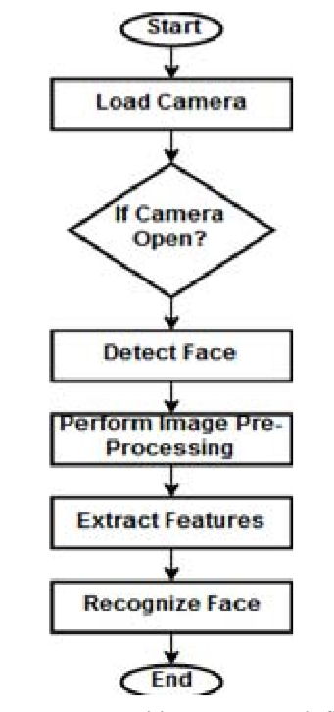

System Work Flow Diagram

Mostly face recognition system includes four main parts: information acquisition module, feature extraction module, classification module and training classifier database module[7]. The image information collected by the learning acquisition module which will be used as a test sample for analysis. In the feature extraction module, which can represent human identity information is extracted and examined. In the classification module, the classifier trained by the database is used to classify test samples to determine the identification information of individuals.

1. Face Detection

We have used OpenCV which presents a Haar cascade classifier, which is used for face detection. The Haar cascade classifier uses the AdaBoost algorithm to detect multiple facial features. First, it reads the image to be detected and converts it into the gray image, then loads Haar cascade classifier to decide whether it contains a human face. If so, it proceeds to examine the face features and draw a rectangular frame on the detected face. Otherwise, it continues to test the next picture.

1. Feature Extraction

The LBP operator is applied to describe the contrast information of a pixel to its neighborhood pixels. The original LBP operator is defined in the window of 3*3. Using the median pixel value as the threshold of the window, it compares with the gray value of the adjacent 8 pixels. If the neighbourhood pixel value is larger or equal compare to the median pixel value, the value of pixel position is marked as 1, otherwise marked as (0) [9]. The function is defined as shown in equation 1. It can be illustrated in Figure 2.

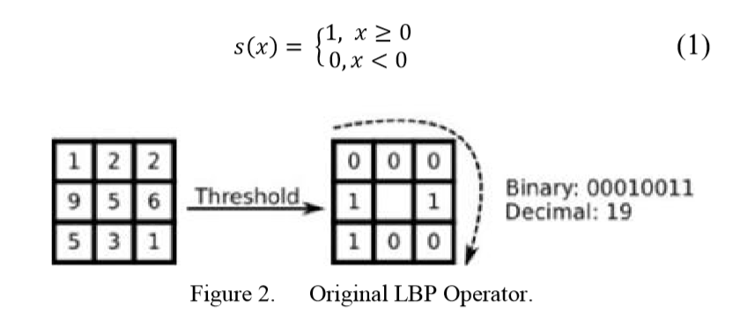

In this way, 8 points in the 3*3 neighbourhood are compared to generate 8-bit binary numbers. Changing it to decimal numbers, the LBP values of the middle pixel points of the window are obtained, which is used to display the texture features of the region. The current LBPH algorithm uses an improved circular LBP operator. It can be represented by Figure 3 and equation 2.

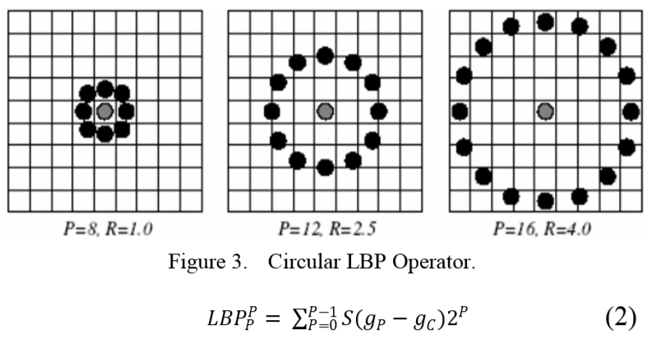

The gray value GP of P neighbourhoods of the pixel C, the radius of which is R. GC is the gray value pixel value C (xc, yc). This algorithm makes the LBP operator no longer limited to fixed radius and neighbourhood and can meet the needs of more different size and texture features. For each pixel of an image, it computes its LBP eigenvalues. Then these eigenvalues can form the LBP feature spectrum. The LBPH algorithm uses the histogram of the LBP characteristic spectrum as the feature vector for classification. It divides a picture into several sub regions, then extracts LBP feature from each pixel of the sub-region, establishing a statistical histogram of the LBP characteristic spectrum in each sub region, so that each sub region can using a statistical histogram to describe the whole picture through a number of statistical histogram components. The advantage is to reduce the error that the image is not fully aligned with a certain range.

III. FACE RECOGNITON ALGORITHM

To perform the face recognition system here the Local Binary Pattern Algorithm has been applied. The LBP operator is used in local features through Local Binary Pattern acts which shorten the local special arrangement of a face image [10]. The LBP operator is the number of binary ratios of pixels intensities within the pixel of center and it’s around eight pixels. It can be shown in below equation.



Where i c indicates the value of the center pixel and (xc, yc), shows eight surrounding pixels information. Therefore, it is very helpful in determining the face features. From the original matrix Features of the image are extracted then these values are compared with the center pixel values, the later binary code is generated. The Algorithm works as below:

1. First, we need to start with temp=0

2. Where I, is the training for each image

3. H=0, then Initialize the pattern histogram

4. Calculate the model label of LBP

5. Keep adding the corresponding bin by 1.

6. Get the greatest LBP feature during each face image and then merging into the unique vector.

7. It's time to compare the features.

8. Finally, if it resembles with the stored database the image is recognized.

***Local Binary Pattern****(LBP) is a simple yet very efficient texture operator which labels the pixels of an image by thresholding the neighborhood of each pixel and considers the result as a binary number.*

It was first described in 1994 (LBP) and has since been found to be a powerful feature for texture classification. It has further been determined that when LBP is combined with histograms of oriented gradients (HOG) descriptor, it improves the detection performance considerably on some datasets.

Using the LBP combined with histograms we can represent the face images with a simple data vector.

As LBP is a visual descriptor it can also be used for face recognition tasks, as can be seen in the following step-by-step explanation.

# Step-by-Step

Now that we know a little more about face recognition and the LBPH, let’s go further and see the steps of the algorithm:

1. **Parameters**: the LBPH uses 4 parameters:

* **Radius**: the radius is used to build the circular local binary pattern and represents the radius around the central pixel. It is usually set to 1.
* **Neighbors**: the number of sample points to build the circular local binary pattern. Keep in mind: the more sample points you include, the higher the computational cost. It is usually set to 8.
* **Grid X**: the number of cells in the horizontal direction. The more cells, the finer the grid, the higher the dimensionality of the resulting feature vector. It is usually set to 8.
* **Grid Y**: the number of cells in the vertical direction. The more cells, the finer the grid, the higher the dimensionality of the resulting feature vector. It is usually set to 8.

Don’t worry about the parameters right now, you will understand them after reading the next steps.

**2.** **Training the Algorithm**: First, we need to train the algorithm. To do so, we need to use a dataset with the facial images of the people we want to recognize. We need to also set an ID (it may be a number or the name of the person) for each image, so the algorithm will use this information to recognize an input image and give you an output. Images of the same person must have the same ID. With the training set already constructed, let’s see the LBPH computational steps.

**3. Applying the LBP operation**: The first computational step of the LBPH is to create an intermediate image that describes the original image in a better way, by highlighting the facial characteristics. To do so, the algorithm uses a concept of a sliding window, based on the parameters **radius** and **neighbors**.

The image below shows this procedure:

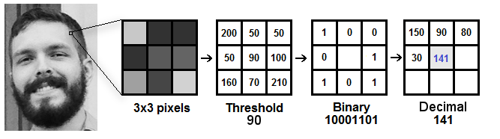

Based on the image above, let’s break it into several small steps so we can understand it easily:

* Suppose we have a facial image in grayscale.
* We can get part of this image as a window of 3x3 pixels.
* It can also be represented as a 3x3 matrix containing the intensity of each pixel (0~255).
* Then, we need to take the central value of the matrix to be used as the threshold.
* This value will be used to define the new values from the 8 neighbors.
* For each neighbor of the central value (threshold), we set a new binary value. We set 1 for values equal or higher than the threshold and 0 for values lower than the threshold.
* Now, the matrix will contain only binary values (ignoring the central value). We need to concatenate each binary value from each position from the matrix line by line into a new binary value (e.g. 10001101). Note: some authors use other approaches to concatenate the binary values (e.g. clockwise direction), but the final result will be the same.
* Then, we convert this binary value to a decimal value and set it to the central value of the matrix, which is actually a pixel from the original image.
* At the end of this procedure (LBP procedure), we have a new image which represents better the characteristics of the original image.
* **Note**: The LBP procedure was expanded to use a different number of radius and neighbors, it is called Circular LBP.

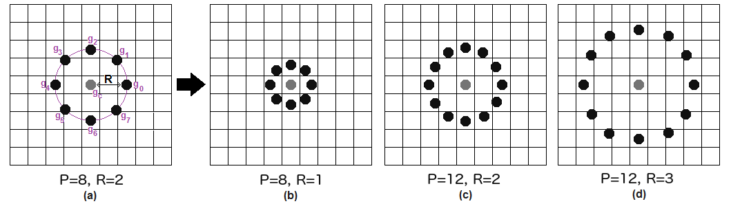

It can be done by using **bilinear interpolation**. If some data point is between the pixels, it uses the values from the 4 nearest pixels (2x2) to estimate the value of the new data point.

**4. Extracting the Histograms**: Now, using the image generated in the last step, we can use the **Grid X** and **Grid Y** parameters to divide the image into multiple grids, as can be seen in the following image:

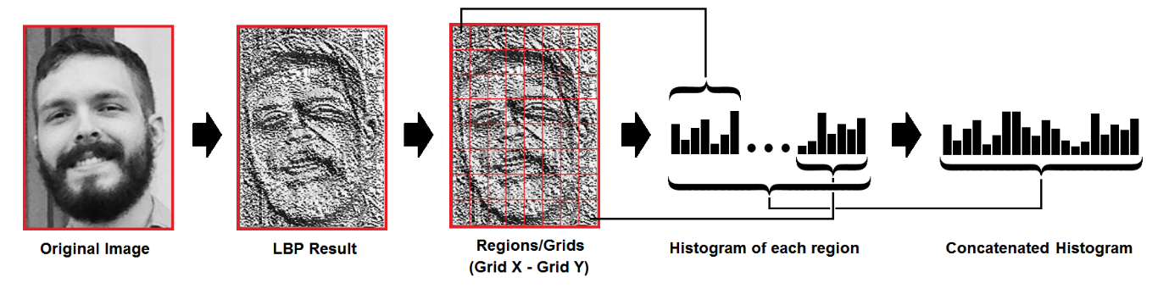

Based on the image above, we can extract the histogram of each region as follows:

* As we have an image in grayscale, each histogram (from each grid) will contain only 256 positions (0~255) representing the occurrences of each pixel intensity.
* Then, we need to concatenate each histogram to create a new and bigger histogram. Supposing we have 8x8 grids, we will have 8x8x256=16.384 positions in the final histogram. The final histogram represents the characteristics of the image original image.

The LBPH algorithm is pretty much it.

**5. Performing the face recognition**: In this step, the algorithm is already trained. Each histogram created is used to represent each image from the training dataset. So, given an input image, we perform the steps again for this new image and creates a histogram which represents the image.

* So to find the image that matches the input image we just need to compare two histograms and return the image with the closest histogram.
* We can use various approaches to compare the histograms (calculate the distance between two histograms), for example: **euclidean distance**, **chi-square**, **absolute value**, etc. In this example, we can use the Euclidean distance (which is quite known) based on the following formula:

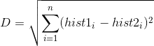

* So the algorithm output is the ID from the image with the closest histogram. The algorithm should also return the calculated distance, which can be used as a ‘**confidence**’ measurement. **Note**: don’t be fooled about the ‘confidence’ name, as lower confidences are better because it means the distance between the two histograms is closer.
* We can then use a threshold and the ‘confidence’ to automatically estimate if the algorithm has correctly recognized the image. We can assume that the algorithm has successfully recognized if the confidence is lower than the threshold defined.

**YOLOv3: Real-Time Object Detection Algorithm**

Object detection is considered to be one of the most challenging tasks in the computer vision field. While there are a handful of different object detection algorithms, in this article, we will have a closer look at YOLOv3 (You Only Look Once). Here, we are using this algorithm for detection of ID Card in the Project.

What is YOLOv3?

YOLOv3 (You Only Look Once, Version 3) is a real-time object detection algorithm that identifies specific objects in videos, live feeds, or images. YOLO uses features learned by a deep convolutional neural network to detect an object. Versions 1-3 of YOLO were created by Joseph Redmon and Ali Farhadi.

The first version of YOLO was created in 2016, and version 3, which is discussed extensively in this article, was made two years later in 2018. YOLOv3 is an improved version of YOLO and YOLOv2. YOLO is implemented using the Keras or OpenCV deep learning libraries.



Object classification systems are used by Artificial Intelligence (AI) programs to perceive specific objects in a class as subjects of interest. The systems sort objects in images into groups where objects with similar characteristics are placed together, while others are neglected unless programmed to do otherwise.

Why the name “you only look once”?

As typical for object detectors, the features learned by the convolutional layers are passed onto a classifier which makes the detection prediction. In YOLO, the prediction is based on a convolutional layer that uses 1×1 convolutions.

YOLO is named “you only look once” because its prediction uses 1×1 convolutions; the size of the prediction map is exactly the size of the feature map before it.

How does YOLOv3 work? (Overview)

YOLO is a Convolutional Neural Network (CNN) for performing object detection in real-time. CNNs are classifier-based systems that can process input images as structured arrays of data and identify patterns between them (view image below). YOLO has the advantage of being much faster than other networks and still maintains accuracy.

It allows the model to look at the whole image at test time, so its predictions are informed by the global context in the image. YOLO and other convolutional neural network algorithms “score” regions based on their similarities to predefined classes.

High-scoring regions are noted as positive detections of whatever class they most closely identify with. For example, in a live feed of traffic, YOLO can be used to detect different kinds of vehicles depending on which regions of the video score highly in comparison to predefined classes of vehicles.



The YOLO Architecture at a Glance

The YOLOv3 algorithm first separates an image into a grid. Each grid cell predicts some number of boundary boxes (sometimes referred to as anchor boxes) around objects that score highly with the aforementioned predefined classes.

Each boundary box has a respective confidence score of how accurate it assumes that prediction should be and detects only one object per bounding box. The boundary boxes are generated by clustering the dimensions of the ground truth boxes from the original dataset to find the most common shapes and sizes.

Other comparable algorithms that can carry out the same objective are R-CNN (Region-based Convolutional Neural Networks made in 2015) and Fast R-CNN (R-CNN improvement developed in 2017), and Mask R-CNN.

However, unlike systems like R-CNN and Fast R-CNN, YOLO is trained to do classification and bounding box regression at the same time.

What’s New in YOLOv3?

There are major differences between YOLOv3 and older versions occur in terms of speed, precision, and specificity of classes. YOLOv2 and YOLOv3 are worlds apart in terms of accuracy, speed, and architecture. YOLOv2 came out in 2016, two years before YOLO v3.

The following sections will give you an overview of what’s new in YOLOv3.

Speed

YOLOv2 was using Darknet-19 as its backbone feature extractor, while YOLOv3 now uses Darknet-53. Darknet-53 is a backbone also made by the YOLO creators Joseph Redmon and Ali Farhadi.

Darknet-53 has 53 convolutional layers instead of the previous 19, making it more powerful than Darknet-19 and more efficient than competing backbones (ResNet-101 or ResNet-152).



Using the chart provided in the YOLOv3 paper by Redmon and Farhadi, we can see that Darknet-52 is 1.5 times faster than ResNet101. The depicted accuracy doesn’t entail any trade-off between accuracy and speed between Darknet backbones either since it is still as accurate as ResNet-152 yet two times faster.

YOLOv3 is fast and accurate in terms of mean average precision (mAP) and intersection over union (IOU) values as well. It runs significantly faster than other detection methods with comparable performance (hence the name – You only look once).

Moreover, you can easily trade-off between speed and accuracy simply by changing the model’s size, without the need for model retraining.



YOLOv3 runs much faster than other detection methods with a comparable performance using an M40/Titan X GPU

Precision for Small Objects

The chart below (taken and modified from the YOLOv3 paper) shows the average precision (AP) of detecting small, medium, and large images with various algorithms and backbones. The higher the AP, the more accurate it is for that variable.

The precision for small objects in YOLOv2 was incomparable to other algorithms because of how inaccurate YOLO was at detecting small objects. With an AP of 5.0, it paled compared to other algorithms like RetinaNet (21.8) or SSD513 (10.2), which had the second-lowest AP for small objects.



YOLOv3 comparison for different object sizes showing the average precision (AP) for AP-S (small object size), AP-M (medium object size), AP-L (large object size)

YOLOv3 increased the AP for small objects by 13.3, which is a massive advance from YOLOv2. However, the average precision (AP) for all objects (small, medium, large) is still less than RetinaNet.

Specificity of Classes

The new YOLOv3 uses independent logistic classifiers and binary cross-entropy loss for the class predictions during training. These edits make it possible to use complex datasets such as Microsoft’s Open Images Dataset (OID) for YOLOv3 model training. OID contains dozens of overlapping labels, such as “man” and “person” for images in the dataset.

YOLO v3 uses a multilabel approach which allows classes to be more specific and be multiple for individual bounding boxes. Meanwhile, YOLOv2 used a softmax, which is a mathematical function that converts a vector of numbers into a vector of probabilities, where the probabilities of each value are proportional to the relative scale of each value in the vector.

Using a softmax makes it so that each bounding box can only belong to one class, which is sometimes not the case, especially with datasets like OID.



Disadvantages of YOLOv3 vs. Other Algorithms

The YOLOv3 AP does indicate a trade-off between speed and accuracy for using YOLO when compared to RetinaNet since RetinaNet training time is greater than YOLOv3. However, the accuracy of detecting objects with YOLOv3 can be made equal to the accuracy when using RetinaNet by having a larger dataset, making it an ideal option for models that can be trained with large datasets.

An example of this would be common detection models like traffic detection, where plenty of data can be used to train the model since the number of images of different vehicles is plentiful. On the other hand, YOLOv3 may not be ideal for using niche models where large datasets can be hard to obtain.

Installing YOLOv3

The YOLOv3 installation is relatively straightforward. Installing some dependencies and libraries is necessary, and after that, it can easily be used for training models. YOLOv3 can be installed either directly onto a computer or through a notebook (such as Google Colaboratory or Jupyter). For both implementations, the commands remain the same. Assuming all libraries have been installed, the command for installing YOLOv3 is pip install YOLOv3.

1. Before installing anything, I’d advise that you make sure the pip version is at least 3.0. You can check the version with the command **pip -V**.  
   If for any reason, you are unable to uninstall older versions of pip or can’t directly use pip version 3, you can use the command “pip3 install ___” rather than just “pip.”
2. Next, we install the required libraries one by one. Starting with OpenCV (Version 3.4 or more recent):**pip install opencv-python**
3. Python (Version 3.6 or more recent): Check if you already have python: **python –version**
4. Install Python for the first time on **Mac or Linux**: brew install python (will need homebrew first if you don’t already have it: **/bin/bash -c “$(curl -fsSL**<https://raw.githubusercontent.com/Homebrew/install/HEAD/install.sh>**)”**)  
   Install Python for the first time on **Windows**: use [this guide](https://phoenixnap.com/kb/how-to-install-python-3-windows). You will need admin privileges on your computer.
5. Tensorflow-gpu (Version 1.5.0 or later): **pip install tensorflow**
6. Keras 2.1.3: **pip install keras**Once you’ve downloaded all the above libraries, you can install YOLOv3 with the command **pip install YOLOv3.**

How to Use YOLOv3

The first step to using YOLOv3 would be to decide on a specific object detection project. YOLOv3 performs real-time detections, so choosing a simple project that has an easy premise, such as detecting a certain kind of animal or car in a video, is ideal for beginners to get started with YOLOv3.

In this section, we will go over the essential steps and what you have to know for using YOLOv3 successfully.

Model Weights

Weights and cfg (or configuration) files can be downloaded from the website of the original creator of YOLOv3: https://pjreddie.com/darknet/yolo. You can also (more easily) use YOLO’s COCO pretrained weights by initializing the model with model = YOLOv3().

Making a Prediction

The convolutional layers included in the YOLOv3 architecture produce a detection prediction after passing the features learned onto a classifier or regressor. These features include the class label, coordinates of the bounding boxes, sizes of the bounding boxes, and more.

Since the prediction with YOLO uses 1 x 1 convolutions (hence the name, “you only look once”), the size of the prediction map is exactly the size of the feature map before it.

In YOLOv3 and its other versions, the way this prediction map is interpreted is that each cell predicts a fixed number of bounding boxes. Then, whichever cell contains the center of the ground truth box of an object of interest is designated as the cell that will be finally responsible for predicting the object. There is a ton of mathematics behind the inner workings of the prediction architecture.

Anchor Boxes

Although anchor boxes, or bounding boxes, were discussed a little bit at the beginning of this article, there is a bit more detail about implementing them and using them with YOLOv3. Object detectors using YOLOv3 usually predict log-space transforms, which are offsets to predefined “default” bounding boxes. Those specific bounding boxes are called anchors. The transforms are later applied to the anchor boxes to receive a prediction. YOLOv3 in particular has three anchors. This results in the prediction of three bounding boxes per cell (the cell is also called a neuron in more technical terms).

Non-Maximum Suppression

Objects can sometimes be detected multiple times when more than one bounding box detects the object as a positive class detection. Non-maximum suppression helps avoid this situation and only passes detections if they haven’t already been detected. Using the NMS threshold value and confidence threshold value, NMS is implemented to prevent double detections. It is an imperative part of utilizing YOLOv3 effectively. Here, we briefly described a few of the features that make the predictions possible, such as anchor boxes and non-maximum suppression (NMS) values. This is, however, not a complete representation of all the features that go into creating a successful prediction with YOLOv3. For full descriptions of YOLOv3’s mathematical background, I suggest reading the official YOLOv3 paper linked at the end of this article.

Interpreting Results

Interpreting the results of a YOLO model prediction is just as nuanced as the actual implementation of the model. Multiple factors go into a successful interpretation and accuracy rating, such as the box confidence score and class confidence score used when creating a YOLOv3 computer vision model. There are many other ways and features used when interpreting results, but these are just a few. Other YOLOv3 prediction features include the classification loss, loss function, objectness score, and more.

Class Confidence and Box Confidence Scores

Each bounding box has an x, y, w, h, and box confidence score value. The confidence score is the value of how probable a class is contained by that box, as well as how accurate that bounding box is.

The bounding box width and height (w and h) are first set to the width and height of the image given. Then, x and y are offsets of the cell in question and all 4 bounding box values are between 0 and 1. Then, each cell has 20 conditional class probabilities implemented by the YOLOv3 algorithm.

The class confidence score for each final boundary box used as a positive prediction is equal to the box confidence score multiplied by the conditional class probability. The conditional class probability in this context is the probability that the detected object is part of a certain class (the class being the object of interest’s identification). YOLOv3’s prediction, therefore, has 3 values of h, w, and depth.

There is some math that then takes place involving the spatial dimensions of the images and the tensors used in order to produce boundary box predictions, but that is complicated. If you are interested in learning what happens during this stage, I suggest the YOLOv3 Arxiv paper linked at the end of this article.

For the final step, the boundary boxes with high confidence scores (more than 0.25) are kept as final predictions.

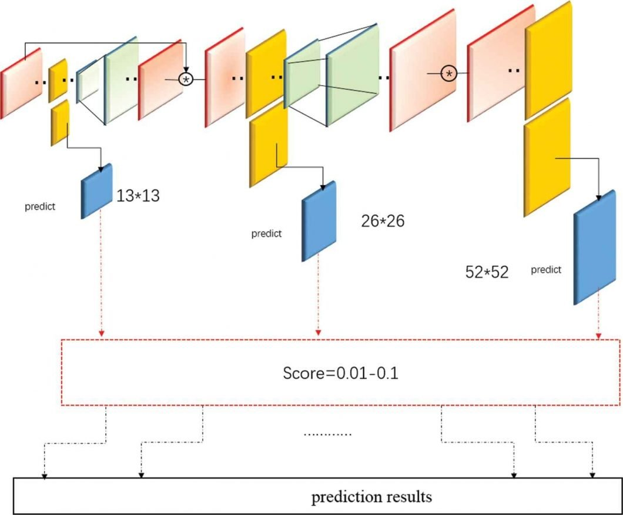

References:

<https://opencv.org/>

<https://ieeexplore.ieee.org/document/9641486>  
<https://ieeexplore.ieee.org/document/9138372>